Week 8 Individual Logbook – Olivia Hey

Hours Breakdown
Category | Hours completed
Team meetings | 5h 45m
Client meetings
Advisor meetings | 2h 45m
Research | 3h
Development
Testing | 45m
Documentation | 15h 15m
Logbook preparation | 1h
Sick leave/specific conditions
Other | 3h
Total Hours for this week | 31h 30m
Running total of hours completed for  Capstone | 156h 45m/450

Completed Content/Documentation

Team Meetings
Monday 12:00pm – 2:30pm, 2h 30m
Team meeting + review over proposal changes + Gantt chart

Tuesday 9:45am – 11:00am, 1h 15m
Weekly logs and final proposal changes.

Friday 10:00am – 12:00pm, 2h
Team meeting to discuss Sam’s Bash script, Matts file processing guide, looking over test cases, choosing necessary metrics. Refer to week 8 meeting minutes.

Advisor Meetings
Monday 10:00am – 12:00pm, 2h
Advisor meeting with Bryce, proposal review.

Tuesday 9:00am – 9:45am, 45m
Advisor meeting with Bryce, proposal review.

Research
Friday 4:00pm – 7:00pm, 3h
Reading the SANS Wireshark guide that Bryce sent.

Testing
Friday 7:00pm – 7:45pm, 45m
Reviewing over a Pcap file for learning.

Documenting
Monday 2:30pm – 5:45pm, 3h 15m
Video editing and review with Matt + making the graph for proposal
Tuesday 11:00am – 12:00pm, 1h
Final changes to the graph + proposal.

Wednesday 2:30pm – 2:45pm, 45m
Writing email & quick document review.

Saturday 2:00pm – 7:00pm, 5h
Evidence handling process document

Sunday 3:00pm – 8:15pm, 5h 15m
Same as above, took ages because word crashes when you try to paste an image into it that was taken on a virtual machine and I had to troubleshoot it and this requires restarting my system every time and the Remote host also crashed. Had to review types of hashing + also made an excel spreadsheet for documenting evidence along with categorising it. The evidence handling document is a full step by step guide with fully documented images and steps.
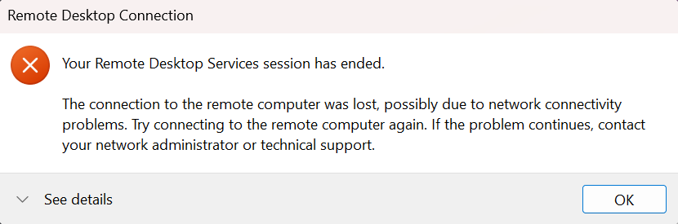

Other
Matter discussed and Approved by Dr Dax Roberts in an email dated 12th of August 2026.

